Sympathetic reaction to others showing signs of being bitten. The best example of this is the scratching by an audience if someone talks about ‘bities’. You may be feeling ‘bities’ by just reading this article.

Delusional Parasitosis – a medical disorder in which the patient has a mistaken belief of being infested by parasites. The sensations in the skin are very real to the sufferer. Scratching leads to rashes and infections. The sufferer applies anything to their skin that they think might provide some relief. Stress – job and personal pressures, divorce, loss of a friend or pet etc – is often a major contributor. There are three types:
Primary psychotic Delusional Parasitosis (DP) where DP is the sole psychological disturbance
Secondary functional DP where the person has an underlying psychiatric condition such as schizophrenia, paranoia, depression, anxiety disorder or obsessional states.
Secondary organic DP where the person has an underlying physical illness such as drug abuse, vitamin B12 deficiency, cancer, hypothyroidism, cerebrovascular disease, tuberculosis, neurologic disorders or diabetes.

If the cause is not from an insect or related animal, any treatment undertaken will not succeed.

THE PEST MANAGER WILL ASK QUESTIONS AND TRY TO IDENTIFY THE PEST – when and where the bites occur – location and parts of the body. Symptoms and suffering are real but are often caused by something other than biting pests. Irritations may become infected and compound the problem. If a likely cause cannot be found medical advice should be sought. Tests can be done to rule out some of the possibilities.

Sufferers of ‘bities’ are often desperate for relief and demand treatment, sometimes gaining short-term relief and demanding re-treatment again and again. The addition of more chemical into their environment may lead to other problems, especially as their plight often causes them to find relief by daubing their skin with unusual concoctions in excess.
THE SENSATION OF BEING BITTEN

You have called out the Pest Manager to treat ‘bities’. You expect he will treat the premises and when he has finished you will not feel any more bites. Is this a correct expectation? The cause of ‘bites’ is often unknown, the solution may only be uncovered by a thorough understanding of the possible causes, by finding answers to the right questions and possibly by seeking medical advice.

The reaction to bites varies between people. Some people appear to be more attractive to insects and/or react more severely to bites. This variance in reaction often makes it difficult to diagnose the cause from the ‘bite’ alone.

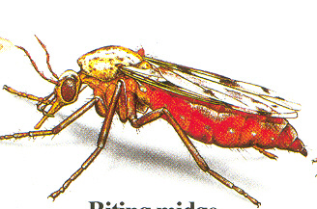
There are a range of causes for the sensation of being bitten, producing symptoms of ‘bites’:
- Insects and related animals
- Physical irritants
- Chemical allergens
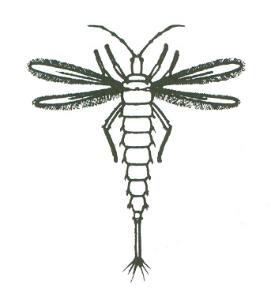
- Sympathetic reaction to others showing signs of being bitten
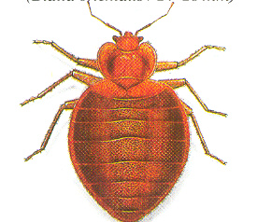
- Delusions of being bitten – these may be stand alone conditions, disease related or drug induced
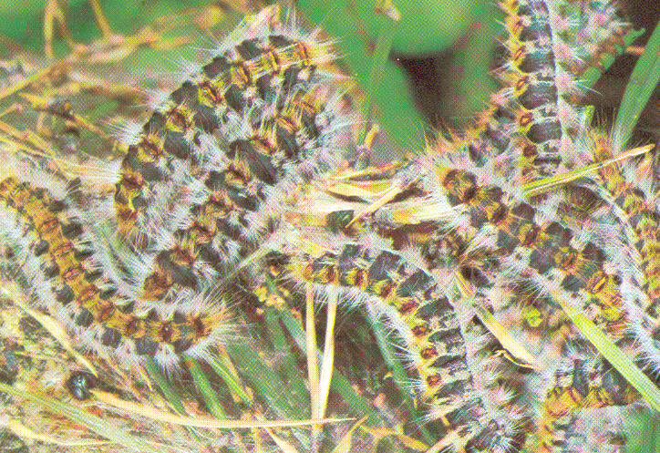
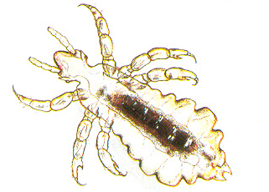

COURTESY OF

Hairy caterpillars
Thrips
YOUR NAME PEST CONTROL
For more information, contact us on
(09) 1234 5678
Visible insects and related animals
Distinct bites on exposed parts of the body, the cause is normally apparent, although the pest may leave before being spotted. Examples include ants, fleas, mosquitoes, bees, spiders and wasps.

‘Invisible’ insects and related animals
Often smaller bites, may be in localized areas.

Bedbugs – bite just before dawn. Blood spots may be found on bedding and dried blood and live insects on the mattress, cracks in furniture and attachments to the wall, curtains and the smooth edge under the carpet. These require a very thorough treatment.

Caterpillar hairs – processionary caterpillars drop stinging (urticating) hairs as they trail and also around their silken shelters. When the hairs touch the body, a stinging sensation results.

Lice – body, head and pubic. These are obligate parasites of people and are medical problems, requiring chemical rinses of the affected parts and washing of clothing/bedding in contact with the body.

Book lice, or psocids, do not have sucking mouthparts so do not bite but their rasping action may cause irritancy.

Midge – or sandflies. Can inflict a painful bite but are not proven to be a vector of disease.

Mites – some bird and rat mites can inflict painful bites. Bird mites are prevalent when the young leave the nest in spring, streaming down one or two walls in the house, looking for their next feed. Long-term control is achieved by removing the hosts and bird proofing the area.

The female scabies mite burrows into the skin to lay eggs and must be treated as a medical problem. Dust mites do not bite, they cause an allergic reaction resulting in asthma.

Thrips – attracted from plants to white washing, biting the unsuspecting person as they put the clothes away.
Physical irritants
The effect is often delayed from the time of contact.

Synthetic and plant fibres – the effect of fibres is felt when they penetrate pores of the skin opened by heat such as in a hot shower. Synthetic fibres are found in some lounge suites and fibreglass insulation. Plant fibres from office paper dust, grass seeds and coconut fibre in hanging pots are common causes of ‘bites’.

Heat rash – especially at change of season where the night temperature fluctuates from day to day – people leave the warm covers on warm nights.

Static electricity – an oldie but a goodie – we understand the zap as we get out of the car on a dry day but imagine that repeatedly in smaller doses for ladies wearing stockings in the dehumidified computer rooms of old. Dry air and static electricity can cause particles of carpet fibres, paper splinters and fibreglass fibres to jump onto arms and legs. These particles feel like little ‘pin pricks’ and cause irritations that feel and may look similar to bug bites. Applying moisture (with or without chemical) will give temporary relief. An anti-static spray may be useful.

Chemical allergens
Contact with chemicals taken internally such as medications and dairy products or by contact such as detergents, perfumes, plant resins and paper dust can cause allergies manifesting themselves as dermatitis and hives.

Medical conditions
Ringworm, hookworm, pinworm and athlete’s foot may cause itching and rashes similar to those from bug bites. Prescription and recreational drugs may cause symptoms consistent with bugs crawling, biting and burrowing into the skin. Other causes are listed below. There is also a possible link to oestrogen deficiencies which would explain the dominance of ‘change of life’ females that report ‘bities.

